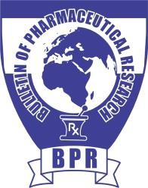

*Bulletin of Pharmaceutical Research* 2024; 14(S1)

An Official Publication of Association of Pharmacy Professionals

**ISSN: 2249-6041 (Print); ISSN: 2249-9245 (Online)**



***AB-00***

**REVOLUTIONIZING TRANSDERMAL THERAPEUTICS: NANOGELS, ESSENTIAL OILS**

**Joshi D. R.**

*IIMT University Ganga Nagar Delhi*

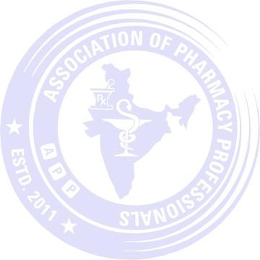

***Email for presenting author:***

This study explores groundbreaking developments in transdermal therapeutics, specifically focusing on the synergistic potential of nanogels and essential oils for advancing colchicine delivery. With the limitations of oral medication administration in mind, researchers are leveraging innovative carriers to navigate skin barriers and enhance permeability for effective transdermal drug delivery. Nanogels, intricate nanoscale polymer-based networks, have shown promise as delivery systems for genes, vaccines, and poorly soluble medications. Additionally, essential oils are considered a non-toxic avenue for improving transdermal penetration. The primary objective of this research is to assess and address colchicine's challenges related to poor permeability and water solubility. The study aims to contribute to the revolutionizing of transdermal therapeutics by enhancing anti-inflammatory action and permeation for improved colchicine delivery. Considering the numerous drawbacks associated with oral medication administration, the transport of active molecules through the skin appears to be an effective technological solution. Therefore, researchers use innovative carriers that can successfully carry out transdermal administration of the molecules in order to get around skin barriers and low skin permeability. The efficient distribution of molecules via the skin is a noteworthy problem that the medical community is working to resolve. Among the methods giving promising outcomes for both dermal and transdermal delivery routes is the use of nanogels. Nanogels are nanoscale polymer-based networks that have been investigated as effective delivery systems for genes, vaccines, and poorly soluble medications. It has been suggested that essential oils are a potential, non-toxic way to improve transdermal penetration. The current study's objective was to assess the colchicine poor permeability and water

solubility.

【**00**】

Presenting Author: Mrs. Iram Jahan E-mail ID: [*iramjhan1@gmail.com*](mailto:iramjhan1@gmail.com)

※※※ **Proceedings of APP-MCOP Collaborative lndo-US International Conference on "Unlocking Horizons in Global Multidisciplinary Health Care on 10 th to 13th March 2025** ※※※



*Bulletin of Pharmaceutical Research* 2024; 14(S1)

An Official Publication of Association of Pharmacy Professionals

**ISSN: 2249-6041 (Print); ISSN: 2249-9245 (Online)**



***AB-00***

**REVOLUTIONIZING TRANSDERMAL THERAPEUTICS: NANOGELS, ESSENTIAL OILS, AND ADVANCEMENTS IN COLCHICINE**

**DELIVERY FOR ENHANCED ANTI-INFLAMMATORY ACTION AND PERMEATION BOOST**

**Deshpande A. S. and Patil Y. D. \***

*PES Modern college of Pharmacy Nigdi Pune , Mahashtra, India*



***Email for presenting author:***

**Introduction:**

**Problem statement:**

**Material and Method:**

**Results and conclusion:**

**Keywords**:

【**00**】

Presenting Author: Mrs. Iram Jahan E-mail ID: [*iramjhan1@gmail.com*](mailto:iramjhan1@gmail.com)

※※※ **Proceedings of APP-MCOP Collaborative lndo-US International Conference on "Unlocking Horizons in Global Multidisciplinary Health Care on 10 th to 13th March 2025** ※※※